Laboratory Investigation of Measles Infection in NVRL

Date: 15/02/2024

Version 2.2

This document summaries testing options for the diagnosis of measles. Testing is currently done in the NVRL. The possibility of regional testing is also under review and this document will be updated.
Rapid testing of suspect measles is recommended for individuals meeting the case definition of measles.
This document outlines the following
- Information to be provided on samples.
- Description of the sample types and testing, transport of specimens to NVRL.
- Diagram describing test results and temporal correlation with symptoms.
- Summary table of samples/tests/and testing scheduling in NVRL

Information to be provided with samples sent to laboratory.
The sample should be labelled with patient name, date of birth- this should be accompanied on the laboratory request form as per NVRL guidance https://nvrl.ucd.ie/info
Oral fluid (Oracol) investigation forms can be downloaded from NVRL https://nvrl.ucd.ie/sites/default/files/uploads/pdfs/LF_UM_001m_rev_10_Oral_Fluid_Investigation_Request_Form.pdf
It is essential that the following information accompanies the sample to determine the significance of the results and appropriate investigations and rapid communication of results.
- Date of rash onset
- Date of sample collection
- Measles containing vaccine history - in particular vaccination if within the last month
- Referring clinician contact number (ideally mobile number)- NVRL will phone results

Description of sample types and testing

Oral fluid (OraCol)
The OraCol collection device provides a non-invasive oral fluid sample which is rich in gingival crevicular fluid (GCV), which is a plasma transudate, which emerges at the margin of the tooth and gum. This transudate contains IgM and IgG derived from plasma but diluted. This sample can be used for the determination of measles IgM. Testing for IgM is more sensitive than using serum in the first few days after rash development and over 50 % may be positive on day 1.
In addition, the oral fluid can be used for the detection of measles RNA (PCR methods) and subsequently sequenced to discriminate between wild type measles genotype and vaccine strain. The oral fluid can be tested for measles RNA during the prodrome of suspected measles infection and up to 7 days post rash onset.
The laboratory results generated are heavily dependent upon the quality of the sample. Therefore, great care is needed to follow the instructions (see Measles Swab Infogram linked below) for collecting the oral fluid, to ensure that there are sufficient cells for measles RNA investigation and antibodies for measles IgM detection.

Measles Swab Infogram [English] [Ukrainian] [Russian] [Turkish] [Georgian] [Arabic] [Pashto] [Somali] [Urdu]
Optimal sample collection
RNA DETECTION: few days before rash develops to seven days post rash. PCR testing is done Monday-Saturday in NVRL (Saturday service commencing 24th February 2024, maximum of 22 samples case be tested). If the sample is received by the NVRL by 9.30 am, the measles RNA result will be available the same day providing the sample is suitable (i.e. sufficient cells). If the result is inconclusive, the sample may be investigated again the next day.
IgM DETECTION: The day the rash develops up to 4 to 5 weeks.

2. Serum samples
Serum samples can be used to detect measles IgM and measles IgG. Measles IgM can be detected 4 days after rash onset. The added value of the serum sample is that measles IgG can also be detected, and this provides information regarding the immune status of an individual following exposure for patient management and also to determine if the infection is a primary infection or breakthrough (reinfection) infection.
In situations when the rash has developed greater than 4 days, a serum sample should be collected, and diagnosis can be confirmed within hours of arrival at the NVRL and this is available 7 days a week. Therefore, this approach could provide a more rapid diagnosis of acute measles infection. If possible, an OraCol sample should be collected in parallel to serum sample for measles RNA determination and genotyping.
Note: Out of hours contact details are available here NVRL out- of- hours service
Optimal sample collection
Measles IgM and IgG: For patients with rash onset greater than 4 days -results available within 2 hours of receipt at the NVRL
Measles IgG: For immune status and breakthrough infection investigation.
Please note that the measles IgG assay was not designed to determine the measles vaccine response. Therefore, whilst the test is useful to guide immediate patient management following exposure to determine susceptibility, the assay should not be used to determine previous vaccine response.
Measles IgM detection using either the OraCol or serum is important to out-rule measles infection and to discard possible cases.

3. Throat swabs or mouth swabs
Throat swabs (VTM or UTM) and mouth swabs (VTM or UTM) can be used to detect Measles RNA within 6 days of rash onset. It is recommended that these samples are collected by a health professional. These sample types are not suitable for IgM investigations.
Optimal sample collection
Throat swabs and mouth swabs: Measles RNA DETECTION ONLY within 6 days of rash onset.
Figure 1. UTM swab
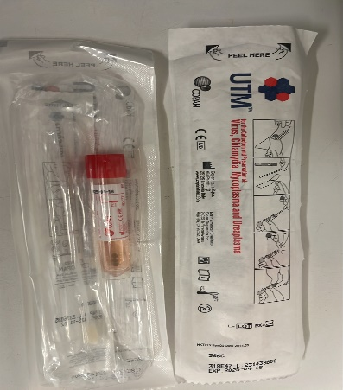

4. Urine and EDTA blood
These sample types are not recommended for measles investigation.

5. Transport of samples to NVRL
- There are scheduled courier services that routinely link hospital laboratories to NVRL, link hospitals to hospitals, and may also be used by primary care practices to send to hospital labs.
- Patients seen Monday-Thursday in primary care
  - GPs are recommended to send samples to the regional/local hospital laboratory- this will allow transport to NVRL the following day as part of routine transport of samples from the local laboratory.
- Patients seen on Friday or Saturday
  - GPs are recommended to contact their local Department of Public Health and request courier service to facilitate rapid turn-around-time in testing and results
- GPs are advised not to send samples to NVRL by post as this leads to delay in diagnosis.

Diagram describing test results and temporal correlation with symptoms

Figure 2. Timeline of measles symptoms and laboratory testing

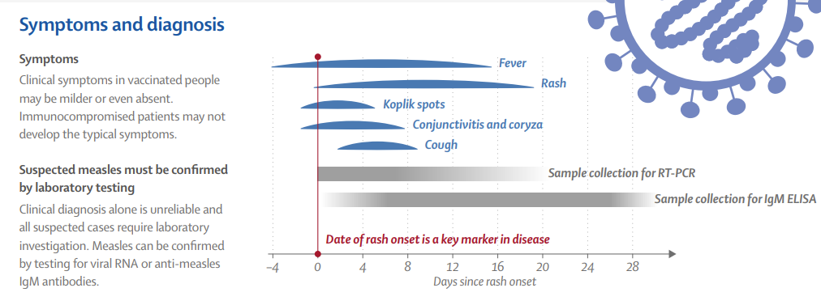
Source: https://www.thelancet.com/pb/assets/raw/Lancet/infographics/measles/image.pdf

IV. Summary table of samples/tests/and testing scheduling in NVRL (as of 09/02/2024)
Table 1 Summary of Sample type, test and availability
Sample type | IgM | IgG | Measles RNA (PCR) | Useful for | NVRL testing available
Oral fluid (OraCol swab) | (day of rash onset up to 4-5 weeks post rash onset) |  | (prodrome and up to 7 days post rash onset) | - Early (pre-rash) measles infection  - Acute measles infection  - Outrule measles infection (discard possible cases based upon IgM result)  - Measles genotyping | - Monday-Saturdayⱡ  - Same day result if sample received at NVRL pre-09:30h*
Serum sample | (4 days post rash onset) |  |  | - Acute measles infection  - Outrule measles infection (discard possible cases)  - Immune status  - Primary infection vs breakthrough infection | - Daily  - Saturday and Sunday by triggering the out of hours service – see https://nvrl.ucd.ie/
Throat/ mouth swab (VTM or UTM) |  |  | (within 6 days of rash onset) | - Acute measles infection  - Measles genotyping | - Monday-Friday  - Same day result if sample received at NVRL pre-09:30h*
EDTA blood | Not recommended
Urine | Not recommended

*; I the sample requires to be retested the result will be available the next day
ⱡ as of 24th February 2024 and based on assessment of need

